**ASSIGNMENT 3**

|  |  |
| --- | --- |
| Assignment Date | 15.10.22 |
| Student Name | S. Nirogini |
| Roll No | 821319104020 |
| Maximum Marks | 2 Marks |

1. Create a bucket in IBM object storage.
2. Upload 5 images to object storage and make it public. Write html code to displaying all the 5 images.
3. 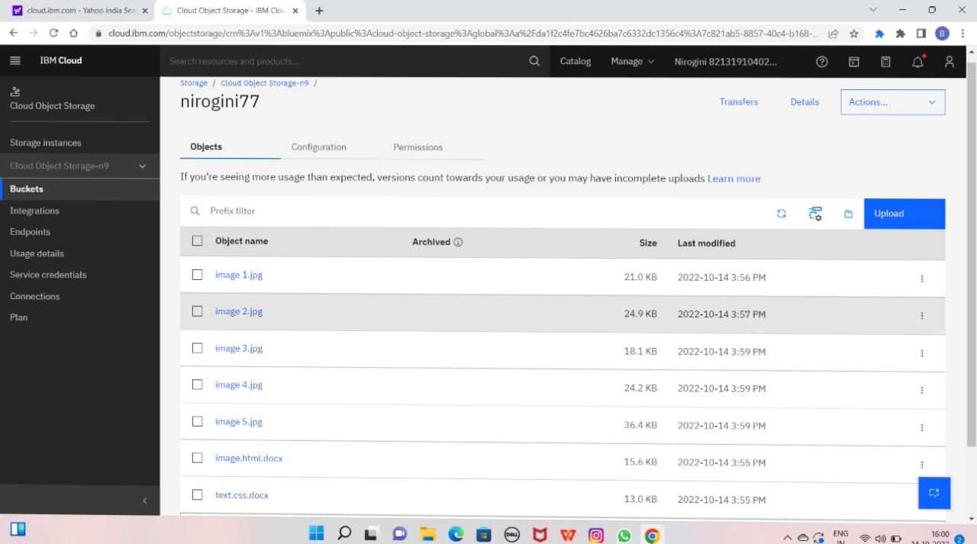Upload a CSS page to the object storage and use the same page in your HTML code.

1. Design a chatbot using IBM Watson assistant for online shopping.

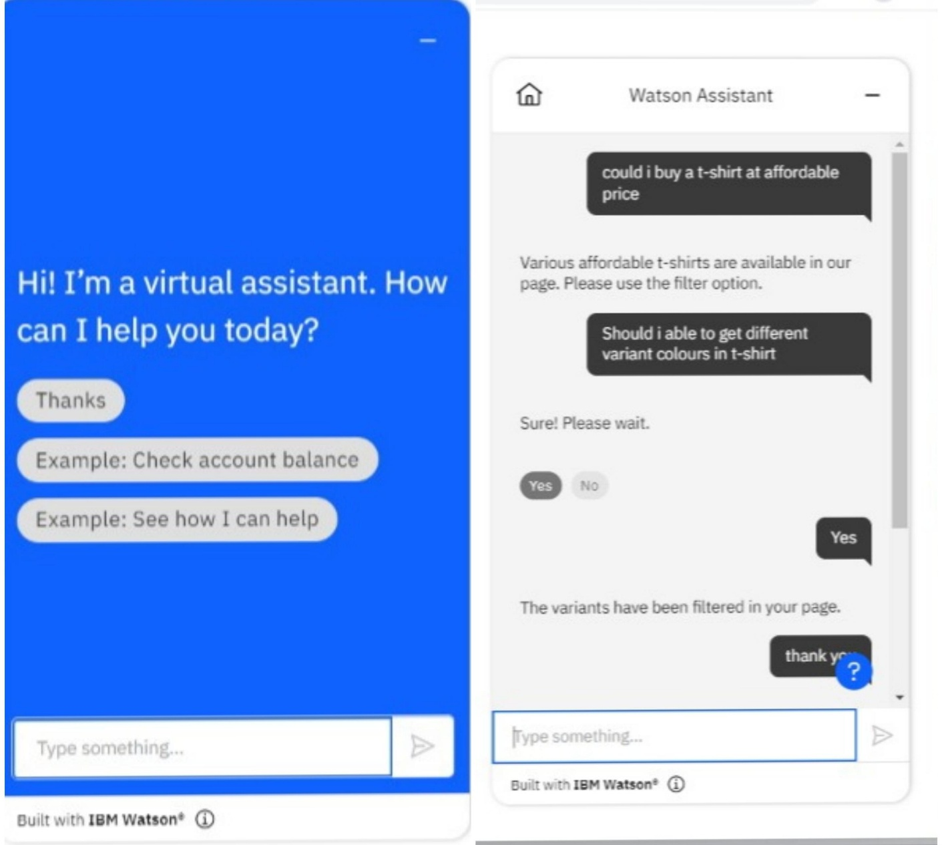

1. Create Watson Assistant Service with 10 steps and 3 conditions. Load that script in HTML page.

